Object oriented programming
LAB FILE

NAME – VANSH MADAAN
BATCH- B4
SAP_ID- 500123857
ROLL_NO - R2142230412
Experiment-5
1. Write a Java program to demonstrate that a private member of a superclass cannot be accessed directly from a derived class.
class Parent { private int a = 10; public int getVar() { return a;
}
}
class Child extends Parent { public void display() {
System.out.println("Value of a = " + getVar());
}
}
public class LAB5_first { public static void main(String[] args) { Child object = new Child(); object.display();
}
}
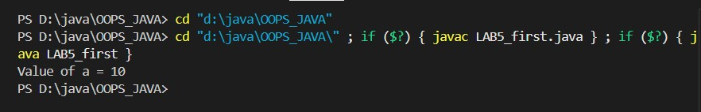
2. Create a Java program with a Player class and derive three subclasses: Cricket_Player, Football_Player, and Hockey_Player. Implement attributes such as name, age, and position, and methods like play() and train() to represent these players.
//error in first_lab5 class Parent { private int a = 10; public int getVar() { return a;
}
}
class Child extends Parent { public void display() {
System.out.println("value if a = " + getVar());
}
}
public class LAB5_first { public static void main(String[] args) { Child object = new Parent(); object.display();
}
}
//output
PS D:\java\OOPS_JAVA> cd "d:\java\OOPS_JAVA"
PS D:\java\OOPS_JAVA> cd "d:\java\OOPS_JAVA\" ; if ($?) { javac LAB5_first.java } ; if ($?) { java LAB5_first }
LAB5_first.java:21: error: incompatible types: Parent cannot be converted to Child
Child object = new Parent();
^1 error
class Player { //parent protected String name; protected int age; protected String position; public Player(String name, int age, String position) { this.name = name; this.age = age; this.position = position;
}
public void play() {
System.out.println(name + " is playing in the position: " +
position);
}
public void train() {
System.out.println(name + " is training.");
}
}
class Cricket_Player extends Player { //child1 public Cricket_Player(String name, int age, String position) { super(name, age, position);
}
@Override public void play() {
System.out.println(name + " is playing cricket as " + position);
}
}
class Football_Player extends Player {//child2 public Football_Player(String name, int age, String position) { super(name, age, position);
}
@Override public void play() {
System.out.println(name + " is playing football as " + position);
}
}
class Hockey_Player extends Player { //child3 public Hockey_Player(String name, int age, String position) { super(name, age, position);
}
@Override public void play() {
System.out.println(name + " is playing hockey as " + position);
}
}
public class LAB5_second { public static void main(String[] args) {
Cricket_Player cricketer = new Cricket_Player("Virat Kohli", 35, "Batsman");
Football_Player footballer = new Football_Player("Cristiano Ronaldo", 39, "Forward");
Hockey_Player hockeyPlayer = new Hockey_Player("Manpreet Singh", 32, "Midfielder"); cricketer.play(); cricketer.train(); footballer.play(); footballer.train(); hockeyPlayer.play();
hockeyPlayer.train();
}
}
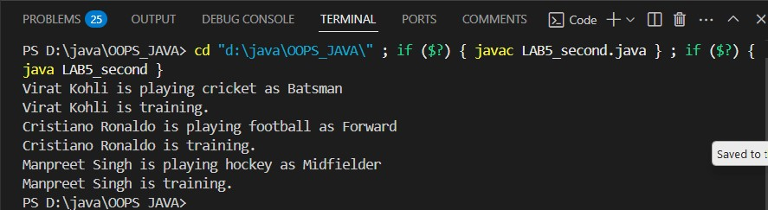
3. A vehicle manufacturing company produces different types of vehicles, such as cars and motorcycles. The base class Vehicle contains common properties like brand, model, and price. The class Car extends Vehicle by adding attributes like seatingCapacity and fuelType. Further, a subclass ElectricCar extends Car, introducing additional attributes like batteryCapacity and chargingTime. The Motorcycle class extends Vehicle and adds engineCapacity and type ( e.g., "Sport", "Cruiser"). Implement this vehicle hierarchy system using multilevel inheritance in Java. Use constructor chaining to initialize attributes efficiently and demonstrate polymorphism by overriding a method displayDetails() in each subclass.
class Vehicle {//parent class protected String brand; protected String model; protected double price; public Vehicle(String brand, String model, double price) { this.brand = brand; this.model = model; this.price = price;
}
public void displayDetails() {
System.out.println("Brand: " + brand);
System.out.println("Model: " + model);
System.out.println("Price: $" + price);
}
}
class Car extends Vehicle {//child class protected int seatingCapacity; protected String fuelType;
public Car(String brand, String model, double price, int seatingCapacity, String fuelType) { super(brand, model, price); this.seatingCapacity = seatingCapacity; this.fuelType = fuelType;
}
@Override public void displayDetails() { super.displayDetails(); System.out.println("Seating Capacity: " + seatingCapacity);
System.out.println("Fuel Type: " + fuelType);
}
}
class ElectricCar extends Car { private int batteryCapacity; private double chargingTime;
public ElectricCar(String brand, String model, double price, int seatingCapacity, String fuelType, int batteryCapacity, double chargingTime) { super(brand, model, price, seatingCapacity, fuelType); this.batteryCapacity = batteryCapacity; this.chargingTime = chargingTime;
} @Override public void displayDetails() { super.displayDetails();
System.out.println("Battery Capacity: " + batteryCapacity + " kWh");
System.out.println("Charging Time: " + chargingTime + " hours");
}
}
// Subclass Motorcycle extending Vehicle
class Motorcycle extends Vehicle { private int engineCapacity; private String type; // e.g., Sport, Cruiser
public Motorcycle(String brand, String model, double price, int
engineCapacity, String type) { super(brand, model, price); this.engineCapacity = engineCapacity; this.type = type;
}
@Override public void displayDetails() { super.displayDetails();
System.out.println("Engine Capacity: " + engineCapacity + " cc"); System.out.println("Type: " + type);
}
}
public class LAB5_third { public static void main(String[] args) {
Vehicle vehicle = new Vehicle("Generic", "Base Model", 15000);
Car car = new Car("Hyundai", "Venue", 15000, 5, "Petrol");
ElectricCar eCar = new ElectricCar("Tesla", "Model S", 80000, 5, "Electric", 100, 1.5);
Motorcycle bike = new Motorcycle("Harley-Davidson", "Street
750", 7500, 750, "Cruiser");
System.out.println("\nVehicle Details:"); vehicle.displayDetails();
System.out.println("\nCar Details:"); car.displayDetails();
System.out.println("\nElectric Car Details:"); eCar.displayDetails();
System.out.println("\nMotorcycle Details:"); bike.displayDetails();
}
}
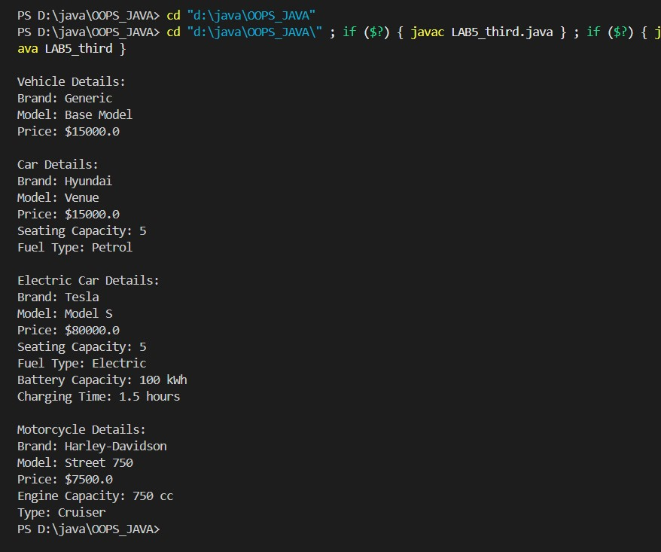
4. Define a Worker class with DailyWorker and SalariedWorker as its subclasses. Each worker has a name and salary rate. Implement a method computePay(int hours) to compute weekly pay. DailyWorker is paid based on the number of days worked (assuming 8 hours per day), whereas SalariedWorker receives a fixed wage for 40 hours per week, regardless of actual hours worked. Use polymorphism to implement this program and test worker salary calculations.
=> class Worker { private String name; private double salaryRate; public Worker(String name, double salaryRate) { this.name = name; this.salaryRate = salaryRate;
}
public String getName() { return name;
}
public double getSalaryRate() { return salaryRate;
}
public double computePay(int hours) { return 0;//default(to be overridden)
}
public void displayWorkerDetails() {
System.out.println("Worker Name: " + name);
System.out.println("Salary Rate: $" + salaryRate + " per hour");
}
}
class DailyWorker extends Worker { public DailyWorker(String name, double salaryRate) { super(name, salaryRate);
}
@Override public double computePay(int hours) { return hours * getSalaryRate();
}
}
class SalariedWorker extends Worker { public SalariedWorker(String name, double salaryRate) { super(name, salaryRate);
}
@Override public double computePay(int hours) { return 40 * getSalaryRate();
}
}
public class LAB5_fourth { public static void main(String[] args) {
Worker dailyWorker = new DailyWorker("John Doe", 20);
Worker salariedWorker = new SalariedWorker("Jane Smith", 25); System.out.println("\nDaily Worker Details:"); dailyWorker.displayWorkerDetails();
System.out.println("Weekly Pay (for 48 hours): $" +
dailyWorker.computePay(48));
System.out.println("\nSalaried Worker Details:"); salariedWorker.displayWorkerDetails();
System.out.println("Weekly Pay (for any hours): $" +
salariedWorker.computePay(50)); // Fixed pay
}
}
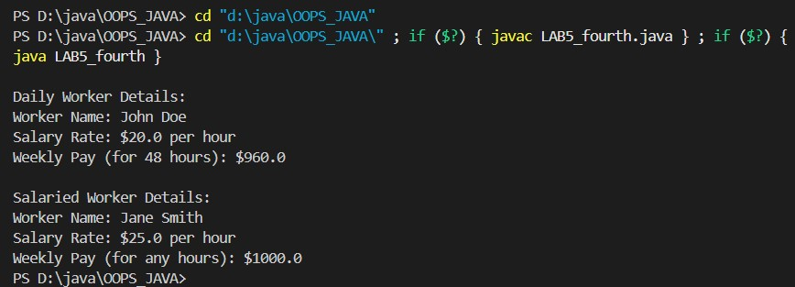
5. You need to design a school management system to illustrate runtime polymorphism in Java. Create a superclass called Person with an abstract method named performDuty(). Next, define two subclasses: Student and Teacher. Each subclass overrides performDuty() in a distinct way, such as printing messages related to studying or teaching. In your main class, create an array or list of Person references, then fill it with instances of both Student and Teacher. Finally, iterate through the array and call the performDuty() method on each element to show that the correct subclass implementation is invoked at runtime, even though all references are of the type Person.
=> import java.util.ArrayList; import java.util.List; abstract class Person { private String name; private int age; public Person(String name, int age) { this.name = name; this.age = age;
}
public String getName() { return name;
}
public int getAge() {
return age;
}
public abstract void performDuty(); public void display() {
System.out.println("Name: " + name);
System.out.println("Age: " + age);
}
}
class Student extends Person { private int rollNo; public Student(String name, int age, int rollNo) { super(name, age); this.rollNo = rollNo;
}
@Override public void performDuty() {
System.out.println(getName() + " is studying for exams.");
}
@Override public void display() { super.display(); System.out.println("Roll No: " + rollNo);
}
}
class Teacher extends Person { private double salary; public Teacher(String name, int age, double salary) { super(name, age); this.salary = salary;
}
@Override public void performDuty() {
System.out.println(getName() + " is teaching a class.");
}
@Override public void display() { super.display();
System.out.println("Salary: " + salary);
}
}
public class LAB5_fifth { public static void main(String[] args) { List<Person> people = new ArrayList<>(); people.add(new Student("Alice", 20, 101)); people.add(new Teacher("Mr. Johnson", 45, 50000)); people.add(new Student("Bob", 22, 102)); people.add(new Teacher("Ms. Smith", 39, 55000)); for (Person person : people) { person.performDuty(); // Runtime polymorphism in action person.display();
System.out.println();
}
}
}
